**Curriculum Vitae**

**{CV}**

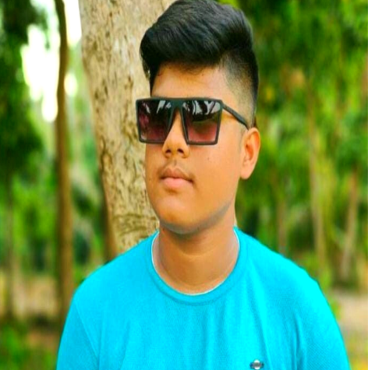

Soumikghosh1908w

032-book.png391-mail4.png067-phone.png001-home.png202-sphere.png016-camera.pngdw e

**EDUCATION**

**The objective of this report is to propose a curriculum for the 3 year Master of Computer Applications (MCA) course. MCA course is now offered by more than 200 institutions all over India and is an important source of human resource for the software industry. Technical Education in 1990.**

**PERSONAL INFO**

**CONTACT**

soumik@gmail.com

Soumikghosh1908

Kolkata, Habra

8653613023

Photography ◼◼◼◼◼

Study ◼◼◼◼◼

**2022-2023**

**HIGHER SECONDARY- Commerce**

**I am a commerce student.**

**Accountancy / Costing / Business studies/ computer application**

**2023 -2026**

**B.C.A - computer application**

**UNIVERSITY OF Adams (M.C.A)**

**Bachelor of Computer Application**

**Percentage:- 98%**

**2026-2027**

**M.C.A – Master of computer application**

**UNIVERSITY OF Adams (M.C.A)**

**Master of Computer Application**

**Percentage:- 89%**

**HOBBIES**

**Logical and organised individual with a strong foundation in software engineering. Proficient in C++, C#, PHP and Java. Seeking to raise coding KPIs by providing error-free codes. Ability to translate business requirements into innovative software solutions. Excellent teamwork, interpersonal and communication skill......**

**PROFILE**



**OBJECTIVE**

**Soumik Ghosh**

**SKILLS**

**Me and My Friend design a portfolio webpage and design a shopping web page..**

**Project 1**

**PROJECTS**

YouTuber

Database Security

Photographer

Web Design

[